**1. Define Django? Write the features of Django?**

Django is a high-level Python web framework that follows the Model-View-Controller (MVC) architectural pattern. It provides a set of tools and libraries that enable developers to quickly and efficiently build web applications. Some features of Django include:

* **Object-Relational Mapping (ORM):** Django provides an abstraction layer for interacting with databases, allowing developers to work with database models using Python code.
* **URL routing:** Django's URL routing system maps URLs to corresponding views, allowing for clean and flexible URL patterns.
* **Template engine:** Django comes with a built-in template engine that allows developers to define the structure and layout of web pages using templates and placeholders.
* **Forms handling:** Django provides a powerful form handling system that simplifies the process of validating and processing form data.
* **Authentication and authorization:** Django includes a robust authentication system that handles user registration, login, and management of user permissions.
* **Admin interface:** Django automatically generates an admin interface based on the defined models, allowing easy management of data through a user-friendly interface.
* **Security features:** Django has built-in protection against common web vulnerabilities such as cross-site scripting (XSS) and cross-site request forgery (CSRF).
* **Internationalization and localization:** Django supports multilingual websites and provides tools for translating text into different languages.

**2. Why do developers prefer Django?**

Developers prefer Django for several reasons:

* **Rapid development:** Django's high-level abstractions and built-in components allow developers to build web applications quickly and efficiently.
* **Scalability:** Django is designed to handle high-traffic websites and can scale easily as the application grows.
* **Reusability:** Django encourages the reuse of code through its modular structure, making it easier to build and maintain large projects.
* **Security:** Django includes security features such as protection against common web vulnerabilities, making it a secure framework for web development.
* **Active community and ecosystem:** Django has a large and active community of developers, which means there are plenty of resources, libraries, and plugins available to extend its functionality.
* **Documentation:** Django has comprehensive and well-maintained documentation, making it easier for developers to learn and use the framework effectively.

**3. write the advantages and disadvantages django?**

**Advantages of Django:**

* **Rapid development:** Django's built-in components and conventions enable fast and efficient development.
* **Scalability:** Django is designed to handle large-scale applications and can be easily scaled as needed.
* **Security:** Django includes built-in security features and follows best practices to protect against common web vulnerabilities.
* **Versatile:** Django can be used to build a wide range of applications, from small websites to complex web systems.
* **Python ecosystem:** Django leverages the extensive Python ecosystem, which provides access to numerous libraries and tools.

**Disadvantages of Django:**

* **Learning curve:** Django has a learning curve, especially for beginners who are new to web development or Python.
* **Overhead:** Django includes many features and components, which may introduce some overhead in terms of performance and complexity for small or simple projects.
* **Convention over configuration:** Django follows a "batteries included" approach, which means it imposes certain conventions and may limit flexibility for developers who prefer more configuration options.

**4. Explain briefly the architecture of django?**

The architecture of Django follows the Model-View-Controller (MVC) pattern, although it is often referred to as Model-View-Template (MVT) in Django. Here's a brief overview of the components in Django's architecture:

* **Models:** Models represent the data structure and define the database schema. They encapsulate the logic for interacting with the database and provide an abstraction layer using Python classes.
* **Views:** Views handle the logic of processing requests and generating responses. They retrieve data from models and pass it to templates for rendering.
* **Templates:** Templates define the structure and layout of the web pages. They contain HTML with placeholders for dynamic content that is filled in by views.
* **URLs and URLconf:** URLs define the routes or patterns that map to specific views. URLconf is a Python module that specifies the URL patterns and maps them to corresponding views.
* **Middleware:** Middleware is a component that sits between the web server and the Django application. It can process requests and responses, perform authentication, logging, or modify the data flow.
* **Forms:** Forms handle the validation and processing of user-submitted data, such as HTML form data. They simplify the process of handling user input and data validation.
* **ORM:** Django's Object-Relational Mapping (ORM) maps Python objects to database tables and provides a high-level API for interacting with the database.

**5. Explain users authentication in django?**

User authentication in Django is handled through the authentication system provided by Django. Here's a brief overview of how user authentication works in Django:

* **User registration:** Django provides built-in views and forms for user registration. Developers can customize the registration process according to their needs.
* **User login:** Django provides views and forms for user login, including support for username/password authentication. Users can log in using their credentials.
* **User sessions:** Django uses session-based authentication, where a unique session is created for each user upon successful login. The session is used to identify the user in subsequent requests.
* **User permissions and access control:** Django includes a robust permission system that allows developers to define access levels and permissions for different parts of the application. It provides decorators and utilities to enforce access control.

**6. What are django templates?**

Django templates are files that define the structure and layout of web pages in Django. They use a combination of HTML and Django template language (DTL) syntax. Django templates allow developers to separate the presentation logic from the application's business logic. Templates can include placeholders for dynamic content, which is filled in by views before rendering the final HTML page. The template system supports template inheritance, filters, loops, conditionals, and more, making it flexible and powerful for generating dynamic web pages.

**7. What is the user session framework?**

The user session framework in Django provides a way to store and retrieve data associated with a particular user across multiple requests. When a user logs in, a session is created and a session ID is stored as a cookie in the user's browser. The session ID is then sent with each subsequent request, allowing the server to retrieve the corresponding session data. The session framework in Django is customizable and supports different backends for storing session data, such as in-memory storage, database storage, or caching systems.

**8. What is the significance of setting.py file in django?**

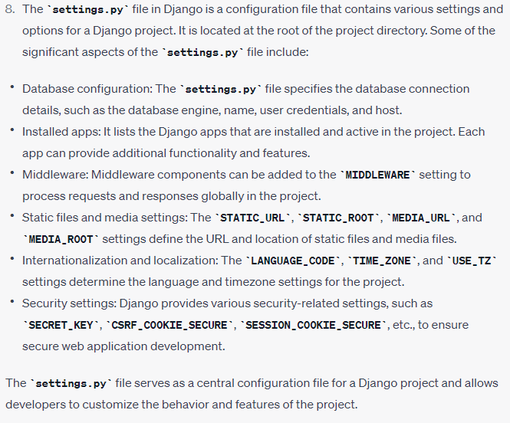

**9. What is the django Rest framework?**

Django Rest Framework (DRF) is a powerful and flexible toolkit for building Web APIs in Django. It provides a set of tools and libraries that simplify the process of building APIs and handling common API-related tasks. Some key features of Django Rest Framework include:

* **Serialization:** DRF provides serializers that allow conversion of complex data types, such as Django models, into JSON, XML, or other content types. It also supports deserialization of incoming request data.
* **Viewsets and routers:** DRF includes viewsets and routers that automate the creation of common CRUD (Create, Retrieve, Update, Delete) operations for API views.
* **Authentication and permissions:** DRF integrates with Django's authentication and permission system, providing authentication classes, token-based authentication, and fine-grained permission control for API endpoints.
* **Pagination and filtering:** DRF offers built-in pagination and filtering options to handle large datasets and enable filtering of API responses based on query parameters.
* **Versioning:** DRF supports versioning of APIs, allowing developers to manage different versions of the API and maintain backward compatibility.
* **Documentation:** DRF generates interactive and browsable API documentation based on the API views and serializers, making it easier for developers to understand and test the API.

**10. What do you see middleware for django?**

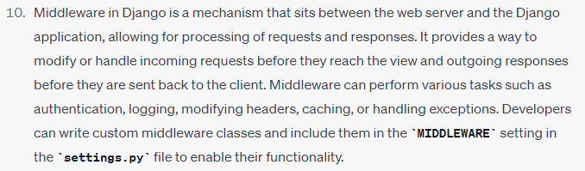

**11. What is session? why session is necessary in a django project?**

In Django, a session refers to a mechanism for storing and retrieving data associated with a specific user across multiple HTTP requests. It allows the server to remember information about a user, such as their authentication status, preferences, or other data, without relying on cookies alone. The session data is stored on the server-side and is referenced by a session ID, which is usually stored in a cookie on the user's browser.

Sessions are necessary in a Django project because they provide a way to maintain stateful behavior in a stateless protocol like HTTP. They enable user-specific functionality and personalization, such as maintaining a user's shopping cart, remembering their login status, or storing temporary data during a multi-step form submission process.

**12. what is django choices? how can it be implemented in django model?**

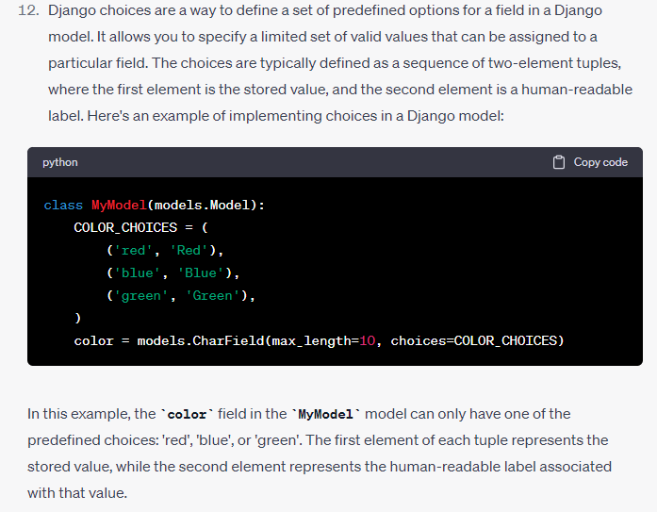

**13. What is the auth model in django? write its advantage?**

The auth model in Django refers to the built-in authentication system provided by Django. It includes a set of models and views that handle user authentication, registration, and permissions. The advantage of the auth model in Django is that it provides a robust and secure way to handle user authentication and authorization without having to build these features from scratch. Some of the advantages of using the auth model in Django are:

* **User management:** The auth model provides a user model that encapsulates common user-related functionality such as registration, login, logout, password management, and user permissions.
* **Authentication backends:** Django's authentication system supports multiple authentication backends, allowing developers to integrate different authentication methods, such as username/password, email/password, or third-party authentication providers.
* **Permissions and groups:** The auth model includes a permissions system that allows developers to define granular access control rules for different users or groups of users.
* **Integration with other Django components:** The auth model seamlessly integrates with other Django components such as the admin interface, forms, and views, making it easy to build secure and authenticated web applications.

By using the auth model in Django, developers can save time and effort by leveraging the pre-built functionality for user authentication and authorization.